***Geodes* in Practice: Evidence of Efficacy and the Role of Implementation**

**Supports in Driving Reading Gains**

Susan B. Neuman

New York University

**Abstract**

This study evaluates the effectiveness of *Geodes®*—a collection of decodable, knowledge-building texts—in improving student reading fluency within the context of a mandated literacy reform. In partnership with a large urban district participating in New York City’s NYC Reads initiative, we examined *Geodes*' role as a bridge between foundational skills and core English Language Arts instruction. Using a design-based, mixed-methods approach, we provided teachers with implementation support, including coaching, lesson routines, and curriculum-aligned progress monitoring. Results demonstrate that students made significant gains in reading fluency over the school year, and classrooms with more consistent *Geodes* use showed the greatest growth. Our findings suggest that while *Geodes* is an effective instructional tool, its impact is enhanced when embedded within a responsive implementation support structure.

**Introduction**

In 2023, New York City launched NYC Reads, a sweeping initiative requiring all elementary schools to adopt curricula aligned with the science of reading. Among the three approved ELA programs, *Wit & Wisdom ®* was selected by District X as its Tier 1 core curriculum. *Wit & Wisdom* offers foundational skills through an integration with Fundations. *Geodes*, a collection of information-rich K-3 books that provide emerging and developing readers with an opportunity to build knowledge while practicing foundational reading skills, is aligned with both programs. Although *Geodes* was not mandated by the district, it was strongly recommended as a Tier 1 instructional resource to strengthen fluency and provide daily practice with connected text.

This study addresses the following research questions:

1. Does student use of *Geodes* result in improved reading fluency?
2. Does the level of *Geodes* implementation influence the degree of student reading gains?
3. What role do implementation supports play in facilitating consistent, effective use of *Geodes*?

**Methods**

**Participants and Setting**

This study took place in 14 first-grade classrooms across District X, a demographically diverse, high-needs urban district in New York City. Forty-five teachers across 38 classrooms participated, including general education and integrated co-teaching classrooms. The participating student sample (n = 405) was evenly split by gender and diverse across racial/ethnic lines.

**Table 1. Demographic Characteristics of Teacher and Student Samples**

|  |  |
| --- | --- |
| **Characteristic** | **Number** |
| Total classrooms | 35 |
| Total teachers | 57 |
| Gender (teachers) | 53 Female, 4 Male |
| Race/Ethnicity (teachers) | 36 White, 11 Asian, 6 Latina, 4 Black |
| Years of teaching | 34 (10+), 17 (5-9), 6 (<5) |
| Student sample | 405 |
| Student gender | 50% Female, 50% Male |
| Race/ethnicity (students) | 49% White, 16% Hispanic, 16% Asian, 13% Black, 4% Multiracial |

**Design and Intervention**

This was a design-based implementation study combining observational, survey, and student outcome data. Teachers were introduced to *Geodes* through an initial workshop, followed by iterative cycles of support, including coaching, planning, and real-time adaptations.

Implementation support included:

* Weekly in-class coaching (avg. 7 visits/class)
* Structured lesson routines for whole and small group use
* Alignment charts linking Fundations, *Geodes*, and Wit & Wisdom
* Progress monitoring

Student fluency was measured using curriculum-aligned passages, capturing Words Correct Per Minute (WCPM), retell quality, and lexical density.

**Results**

**Student Outcomes by Geodes Usage Level**

Student reading fluency gains were positively associated with the level of Geodes use. A one-way analysis of covariance (ANCOVA) controlling for pretest scores revealed a significant effect of implementation level on posttest Words Correct Per Minute (WCPM) gains, *F*(2, *N*) = 4.33, *p* < .013, η² = 0.068, indicating that approximately 7% of the variance in student gains was explained by differences in Geodes use. Post-hoc comparisons (Tukey’s HSD) showed that:

* Students in classrooms with consistent Geodes use (Level 1) made significantly larger gains than those in classrooms with **limited use (Level 2)** or **minimal/no use (Level 3)**.
* Students in classrooms with **limited use (Level 2)** also outperformed those in **minimal/no use (Level 3)** settings.

Across all classrooms, students made measurable gains from fall to spring, but the size of those gains differed meaningfully by implementation level, with the strongest outcomes in classrooms that fully integrated Geodes into Tier 1 instruction.

### **Table 2. Typology of Geodes Use Across Classrooms**

|  |  |  |  |  |
| --- | --- | --- | --- | --- |
| **Level** | **Description of Use** | **Frequency & Duration** | **Instructional Context** | **No. of Classrooms** |
| **Level 1: Consistent Use** | Geodes used regularly across whole-class, small-group, and independent settings with strong alignment to core materials. | 3–4x/week; 20–45+ mins total weekly | Whole group intro, frequent small groups, some independent practice | 16 |
| **Level 2: Limited Use** | Geodes used regularly in small groups 2–3x/week, often for targeted skills or fluency; limited whole-group integration. | 2–3x/week; 15–30 mins total weekly | Primarily small group, occasional whole group | 13 |
| **Level 3: Minimal/No Use** | Geodes rarely or never used for instruction; may be available informally in classroom libraries. Barriers include time, perceived difficulty, or misalignment. | Rare or none | None or unstructured access only | 6 |

**Figure 1. Adjusted Post WCPM by Geodes Usage Level**

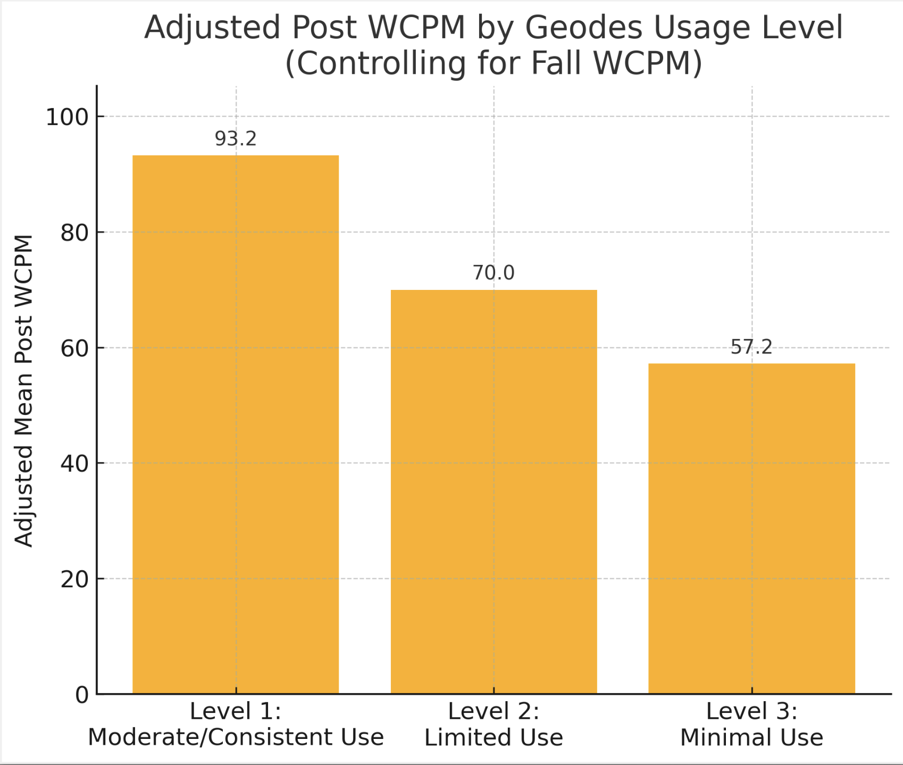

**Implementation Supports and Teacher Uptake**

Survey, interview, and observational data revealed that the following supports were most strongly associated with consistent *Geodes* use:

* Ready-to-use lesosn plans and slides
* Student-focused coaching that modeled routines in context
* Aligned progress monitoring that visualized student growth
* High-leverage routines for fluency and comprehension

Teachers reported that these supports improved their confidence and reduced planning burdens. Classrooms that received more coaching visits were significantly more likely to fall into Level 1 or 2 use categories.

**Discussion and Implications**

This study provides compelling evidence that Geodes, when implemented regularly and supported through structured implementation tools, drives meaningful gains in student reading fluency. Students in classrooms with higher levels of Geodes integration showed the greatest improvements, confirming the efficacy of the materials themselves.

Importantly, this research also highlights that materials alone are not enough. Implementation supports—such as student-centered coaching, ready-to-use routines, and curriculum-aligned progress monitoring—played a critical role in increasing teacher uptake and instructional coherence. Classrooms that received targeted, hands-on support were more likely to use Geodes consistently and purposefully, enabling more students to benefit from decodable, content-rich connected texts.

These findings align with broader implementation science, suggesting that support mechanisms which elevate teacher voice and fit can increase the impact of even high-quality programs. For district leaders and policymakers, this underscores the value of pairing mandated programs with responsive, on-the-ground instructional supports. Doing so helps ensure that strong materials like Geodes are not only adopted but implemented in ways that lead to meaningful student outcomes.

In the context of large-scale reform efforts like NYC Reads, these results suggest that embedding Geodes as a standard part of the literacy block—especially when accompanied by structured supports—can provide an effective and scalable strategy to improve early literacy achievement.

**References**

Biggs, E., & Hacker, R. (2021). Engaging stakeholders to improve social validity: Intervention priorities for students with complex communication needs. *Augmentative and Alternative Communication*, 37, 25-38.

Birken, S. et al. (2020). Advancing understanding and identifying strategies for sustaining evidence-based practices: A review of reviews. *Implementation Science*, 15(88).

Braun, V., & Clarke, V. (2006). Using thematic analysis in psychology. *Qualitative Research in Psychology*, 3, 77-101.

Bryk, A. S., Gomez, L. M., Grunow, A., & LeMahieu, P. G. (2015). *Learning to improve: How America’s schools can get better at getting better*. Harvard Education Press.

Domitrovich, C. E., et al. (2008). Maximizing the implementation quality of evidence-based preventive interventions in schools: A conceptual framework. *Advancing School Mental Health Promotion*, 1(1), 6–28.

Fixsen, D. L., et al. (2005). *Implementation research: A synthesis of the literature*. University of South Florida.

Hasbrouck, J., & Michel, D. (2022). *Student-focused coaching*. Paul H. Brookes Publishing.

Hasbrouck, J., & Tindal, G. (2017). *Oral reading fluency norms: 2017 update*. Read Naturally.

Hiebert, E. H. (2024). Enhancing opportunities for decoding and knowledge building through beginning texts. *The Reading Teacher*. <https://doi.org/10.1002/trtr.2303>

Kraft, M. A., Blazar, D., & Hogan, D. (2018). The effect of teacher coaching on instruction and achievement: A meta-analysis of the causal evidence. *Review of Educational Research*, 88(4), 547–588.

Mandler, J. M., & Johnson, N. S. (1977). Remembrance of things parsed: Story structure and recall. *Cognitive Psychology*, 9, 111–151.

Wheeler, J. J., & Carter, S. L. (2019). *The social validity manual: Subjective evaluation of interventions*. Academic Press.

Wolf, M. M. (1978). Social validity: The case for subjective measurement or how applied behavior analysis is finding its heart. *Journal of Applied Behavior Analysis*, 11(2), 203–214.